**Red King Crab Chela Measurements**

* 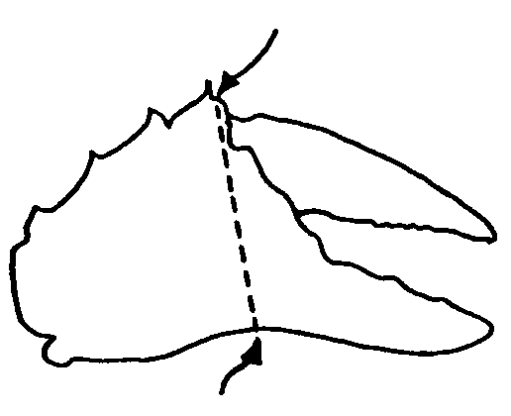Measure right chela of males with both chelae intact and record carapace width and chela height to nearest 0.1 mm.

(Measure from the shelf forward of the first spine)

* Record measurements along with vessel, cruise, haul and date on the Crab Data Forms provided.
* **If Tanner crab are present in the haul, sample Tanner crab and not red king crab**
* To ensure small, medium, and large crab are sampled throughout the survey, **for each haul, measure 5 crab from each of the 3 size categories 1) <95 mm CL, 2) 95-134 mm CL, and 3) > 134 mm CL for a total of 15 crab.** It is likely that all sizes will not be caught in each haul so less than 15 crab will be measured for many hauls.
* Each of the 3 larger size categories above are further broken down into 10 mm size bins (except the smallest and largest size bins are larger). The goal is to sample a minimum of 20 crab per 10 mm size bin per boat.
* Enter the data on the forms into the crab data spreadsheet (2014 Crab Data_<vesselname>.xls). Bring the completed forms along with the spreadsheet file on the thumb drive back to Kodiak at the end of each leg.

**Size bins CL mm Minimum sampling goal per boat**

<65 mm 20

65-74 20

75-84 20

85-94 20

95-104 20

105-114 20

115-124 20

125-134 20

135-144 20

145-154 20

155-164 20

165-174 20

>175 20

**Boat 1 Red King Crab Chela Measurements Tally Sheet**

|  |  |
| --- | --- |
| **Size Bins CL mm** | **Minimum sampling goal is 20 per boat** |
| **<65** |  |
| **65-74** |  |
| **75-84** |  |
| **85-94** |  |
| **95-104** |  |
| **105-114** |  |
| **115-124** |  |
| **125-134** |  |
| **135-144** |  |
| **145-154** |  |
| **155-164** |  |
| **165-174** |  |
| **>174** |  |

**Boat 2 Red King Crab Chela Measurements Tally Sheet**

|  |  |
| --- | --- |
| **Size Bins CL mm** | **Minimum sampling goal is 20 per boat** |
| **<65** |  |
| **65-74** |  |
| **75-84** |  |
| **85-94** |  |
| **95-104** |  |
| **105-114** |  |
| **115-124** |  |
| **125-134** |  |
| **135-144** |  |
| **145-154** |  |
| **155-164** |  |
| **165-174** |  |
| **>174** |  |